Vvedensky, Aleksandr Ivanovich (ВВЕДЕНСКИЙ, АЛЕКСАНДР ИВАНОВИЧ) (1904-41)

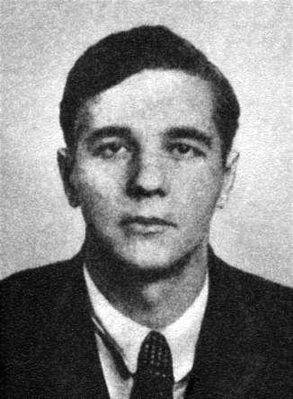Known during his lifetime as a failed avant-gard poet who went on to a successful, if minor, career as a children's writer, Vvedensky is today acknowledged one of the most important voices of the Leningrad poetic avant-garde in the late 1920s and 1930s. A co-founder of the short-lived but influential «Obedinenie real'nogo iskussta» or OBERIU (The Association for Real Art), Vvedensky is one of the creators of Russia's first literature of the Absurd. Starting from the premise that language and logic were unable to convey the truth of reality, Vvedensky rejected the traditional conventions of Russian poetry and sought the key to human cognition in the concept of the absurd (*bessmyslitsa*). Profoundly out of synch with the philosophical values and literary norms of emerging Stalinist culture and hounded by an increasingly hostile critical establishment, Vvedensky was arrested in 1931 and again in 1941, when he died in the custody of the NKVD. After his arrest and death, most of his manuscripts, tragically, were destroyed, and he was almost completely forgotten until the 1970s, when the process of returning his legacy to the history of Russian literature began.

**References and Further Reading**:

*Poet Aleksandr Vvedenskii: sbornik materialov.* Eds. K. Ichin. S. Kudriavtsev. Belgrad and Moscow; Gileia, 2006. Excellent collection of articles by leading Russian and international scholars, including a detailed chronicle of Vvedensky's life and career.

*«Sborishche druzej ostavlennykh sud'boiu»: A. V. Vvedenskii, L. Lipavskii, Ia. Druskin, D. Kharms, N. Oleinikov: «chinari» v tekstakh, dokumentakh i issledovaniiakh*. Eds. V. Sazhin, A. Dmitrenko et al. 2 vols. Moscow: Ladomir, 1998. Valuable collection of documents by Vvedensky and his closest literary collaborators that also includes important historical and critical articles.

Graham Roberts, *The Last Soviet Avant-Garde: OBERIU – Fact, Fiction, Metafiction.* Cambridge: Cambridge University Press, 1997. Extremely useful study of the lives and works of the OBERIU and its significance in the history of the Russian avant-garde.

Alice Stone-Nakhimovsky, *Laughter in the Void: An Introduction to the Writings of Daniil Kharms and Alexander Vvedenskii*. Vienna: Wiener Slavistischer Almanach, 1982. Good introduction to the techniques, literary themes and philosophical concerns of the two main writers of the OBERIU.

Iuliia Valieva, *Igra v bessmyslitsu: poeticheskii mir Aleksandra Vvedenskogo*. St. Petersburg: Bulanin, 2007. Philosophical study of central concepts (e.g., "time," "space," "absurd") that structure Vvedensky's poetical universe.

**Works**:

*Vse*. (*Everything*). Ed. A. Gerasimova. Moscow: OGI, 2011. [Includes all of Vvedensky's surviving works, as well as chronicle of his life and works, and important critical, biographical, and memoiristic works.]

*Polnoe sobranie sochinenii*. Eds. M. Meilakh and V. Erl'. Moscow: Gileia, 1993.

*Polnoe sobranie sochinenii*. Ed. M. Meilakh. 2 vols. Ann Arbor: Ardis, 1980-84.

*An Invitation for Me to Think*. Trs. E. Ostashevsky & M. Yankelevich. NY: NYRB, 2013.

*OBERIU: An Anthology of Russian Absurdism*. Ed. E. Ostashevsky. Evanston: Northwestern University Press, 2006.

*The Grey Notebook*. Trs. M. Yankelevich. New York: Ugly Duckling Press, 2002.

*The Man with the Black Coat: Russia's Literature of the Absurd*. Trs. G. Gibian. Evanston: Northwestern University Press, 1997 (Originally published 1971).

**Anthony Anemone, The New School**

Source url for image: https://ru.wikipedia.org/wiki/Введенский,_Александр_Иванович_(поэт)